Recent Memory Problems

Question 4 (Retake Spring 2016) Cache Modeling

- A word-addressable computer has a 2-way set associative 1KB cache with a block size of 64 bits. Assume that the main memory is a 256KB memory. Explain the address format used to access this cache in a 16-bit processor.

256KB = 2^18bytes, 2^18bytes/2^2bytes; addresses are 16 bits
Block size = 64/8 = 8 bytes/4bytes = 2=2^1
1KB/2 = 2^9 bytes for each way, 2^9/2^3 = 2^6 blocks in each way, therefore

Tag: 9 bits
Index/Set: 6 bits
Offset: 1 bit
Byte Offset 0 bits, since blocks are 4 bytes
Block Offset 1 bit, since there are 2 words in each 64-bit block

- Consider a 2-way set associative 1KB cache with a block size of 16 bytes, where main memory is a byte-addressable 256KB memory. Consider the following read pattern (addresses) repeats for 1000 times assuming that cache replacement policy is LRU:

  - 0x12AB0
  - 0x2A4B1 //It loads block offsets 00, 01, 10, 11 in same block too
  - 0x0038F
  - 0x3FEB8
  - 0x2A4BF
  - 0x3FEB0

What is the hit rate? Explain in detail.

256KB = 2^18, addresses are 18 bits
Block size = 16/4 = 2^2 words/block
1KB/2 = 2^9 bytes for each way, 2^9/2^4 = 2^5 blocks in each way, therefore

Tag: 9 bits
Index/Set: 5 bits
Offset: 4 bits
Byte Offset 2 bits, since there are 4 bytes per word
Block Offset 2 bit, since there are 4 words in each 16-byte block

Expanding the memory references into binary, and grouping by Tag, Index, and Offset:

- 0x12AB0 → 01 0010 1010 1011 0000
- 0x2A4B1→ 20 1010 0100 1011 0001
- 0x0038F→ 00 0000 0011 1000 1111
- 0x3FEB8→ 11 1111 1110 1011 1000
- 0x2A4BF→ 20 1010 0100 1011 1111
- 0x3FEB0→ 11 1111 1110 1011 0000

From this we see that references 1, 2, 4, and 5 are in the same index/set. Since this is 2-way set associative, it will tolerate some conflicts. 2 and 5 are to the same block which makes it hit after the first compulsory miss. However, 1 and 4 will keep kicking one out causing conflict misses. On the other hand, 6 will always enjoy a hit due to spatial locality of 4. So here are the misses in each iteration:
1,4 → different tags 2,5 → same tag different block offset
1st iteration -> M M M M H H
2nd iteration -> M H H M H H
3rd iteration -> M H H M H H
…..
So the result will be ~1/3 misses, ~ 2/3 hits.

To be exact: Miss Rate = (2 * 999 + 4) / (6*1000) = 2002/6000, so Hit Rate = 3998/6000

Question 3 b c (Final Spring 2016): Memory

The following 3 parts are independent of each other, you should answer each as if it is a separate question.

b) (Assume you have two CPUs: X and Y, each with one level of cache. The cache size is 128 bytes, the cache block size is 32 bytes, and the cache uses LRU replacement. The only difference between the CPUs is the associativity of the cache: X uses a direct mapped cache, whereas Y uses a fully associative cache. A benchmark is executed assuming that the cache is empty before execution. The cache accesses generated by the program are as follows, in order of access from left to right:

A, B, A, H, B, G, H, H, A, E, H, D, H, G, C, C, G, C, A, B, H, D, E, C, C, B, A, D, E, F

Each letter represents a unique cache block. All 8 cache blocks are contiguous in memory. However, the ordering of the letters does not necessarily correspond to the ordering of the cache blocks in memory.

- For X, you observe the following cache misses in order of generation:

A, B, A, H, B, G, A, E, D, H, C, G, C, B, D, A, F

By using the above trace, identify which cache blocks are in the same set for X processor.

A and B //First A compulsory miss, then B is miss since same set as A and direct mapped
C and G
H and D //First H compulsory miss then D miss since same set as H etc.
E and F

- Write down the sequence of cache misses for the Y processor in their order of generation. (Hint: You might want to write down the cache state after each request).

By simulating the cache and using the requests:

Req: | A | B | A | H | B | G | H | H | A | E | H | D | H | G | C | C | G | C | A | B | H | D | E | C | C | B | A | D | E | F
Miss? | x | x |  | x |  | x |  |  |  | x |  | x |  | x | x |  |  |  | x | x | x | x | x | x |  | x | x | x | x | x
MRU: | A | B | A | H | B | G | H | H | A | E | H | D | H | G | C | C | G | C | A | B | H | D | E | C | C | B | A | D | E | F
: | - | A | B | A | H | B | G | G | H | A | E | H | D | H | G | G | C | G | C | A | B | H | D | E | E | C | B | A | D | E
: | - | - | - | B | A | H | B | B | G | H | A | E | E | D | H | H | H | H | G | C | A | B | H | D | D | E | C | B | A | D
LRU: | - | - | - | - | - | A | A | A | B | G | G | A | A | E | D | D | D | D | H | G | C | A | B | H | H | D | E | C | B | A

The misses are: A B H G E D G C A B H D E C B A D E F

c) In a 64-bit processor, a 16-way set-associative cache is designed where data words are 64 bits long and
are addressed to the half-word. Cache holds 2 Mbytes of data with each block holding 16 data words.
Each cache line has two additional bits used to indicate whether the cache line is “valid” and/or “dirty”.

  - How many bits of tag, index, and offset are needed to support references to this cache?
  - What is the actual size of the cache in hardware?

- We can calculate the number of bits for the offset first:

- There are 16 data words per block which implies that at least 4 bits are needed
- Because data is addressable to the ½ word, an additional bit of offset is needed
- Thus, the offset is 5 bits

To calculate the index, we need to use the information given regarding the total capacity of the cache:
- 2 MB is equal to 2^21 total bytes.
- We can use this information to determine the total number of blocks in the cache…
2^21 bytes x (1 block / 16 words) x (1 word / 64 bits) x (8 bits / 1 byte) = 2^14 blocks

- Now, there are 16 (or 2^4) blocks / set
Therefore there are 2^14 blocks x (1 set / 2^4 blocks) = 2^10 or 1024 sets
- Thus, 10 bits of index are needed
Finally, the remaining bits form the tag:
- 64 – 5 – 10 = 49
- Thus, there are 49 bits of tag
To summarize: Tag: 49 bits; Index: 10 bits; Offset: 5 bits

- Each cache line has 16 words * 64 bits/word = 1024 bits for data + 49 bits for tag + 2 bits = 1075 bits per cache line. There are 2^10 cache lines, therefore 2^10 * 1075 bits in one way. There are 2^4 ways. Total: 2^4 * 2^10 * 1075 bits ~ 2.1MB

Question 5 (MT #2 Spring 2016) Virtual Memory

You are given the following 4-entry, fully-associative TLB that has a least-recently-used (LRU) replacement policy. Note that ‘1’ means “Most Recently Used and ‘4’ means “Least Recently Used”. In addition to the TLB, for a process, the following page table is also given. Virtual memory addresses are given in 16 bits.

TLB Page Table
Valid | LRU | Virtual Page | Physical Page
1 | 3 | 1100 | 100
1 | 4 | 0011 | 010
1 | 2 | 1001 | 110
1 | 1 | 0100 | 101

Virtual Page Number | Valid | Physical Page Number
0000 | 0 | 001
0001 | 1 | 001
0010 | 1 | 000
0011 | 1 | 010
0100 | 1 | 101
0101 | 0 | 010
0110 | 1 | 011
0111 | 0 | 010
1000 | 0 | 100
1001 | 1 | 110
1010 | 1 | 111
1011 | 0 | 101
1100 | 1 | 100
1101 | 0 | 110
1110 | 0 | 100
1111 | 0 | 001

- (3 points) What is the page size?

16 – 4 = 12 bits for page offset.
2¹² = 4KB pages.

- How big is the physical memory?

2³ = 8 physical pages exist. 8 * 4KB = 32KB physical memory space is available.

- For the following virtual addresses, what physical address is calculated in HEX? In this system, disk access time is 50000 cycles, whereas, memory access time is 100 cycles, and TLB access time is 4 clock cycles. What will be the time required to retrieve the data?

  - 1100 0010 0010 0100
  - 0000 0101 0011 0110
  - 1001 1110 0110 1110
  - 1010 0000 1000 0011

- VPN: 1100 → 100 TLB Hit. Physical address: 100 0010 0010 0100 – 0x4224
Time: Access TLB – 4 + Bring data – 100 = 104
- VPN: 0000 → TLB Miss. Page Table : Page Fault (No physical address)
Time: Access TLB – 4 + Page Fault – 100 + Disk access – 50000 = 50104
- VPN: 1001 → 110 TLB Hit. Physical address: 110 1110 0110 1110 – 0x6E6E
Time: Access TLB – 4 + Bring data – 100 = 104
- VPN: 1010 → TLB Miss. Page Table : Hit -
Physical address: 111 0000 1000 0011 – 0x7083
Time: Access TLB – 4 + Page Table – 100 + Bring data – 100 = 204

- Consider a different virtual memory system with 32 bit virtual addresses and 65,536 (2^16) byte pages. Moreover, each page table entry has: 1 valid bit, 1 dirty bit, and the physical page number. If the physical memory is 1GB, how much memory would we need to simultaneously hold the page tables for two different processes?

VPN is 16 bits long – so each page table will have 2¹⁶ entries
Page offset = 32 – 16 = 16 bits
Physical page number is 30 – 16 = 14 bits

Each page table entry will hold the above 14 bit PPN + 1 valid bit + 1 dirty bit
- Thus, each page table entry is 2 bytes.
- There are 2¹⁶ 2-byte entries per process
- Thus, each page table requires 2¹⁷ bytes or ~128 Kbytes
- Because each process has its own page table, a total of 2¹⁸ bytes or ~256 Kbytes are needed

Question 4 (MT #2 Spring 2016) Cache modeling and tracing

Part 1 An embedded 16-bit processor has 32 Mbytes of main memory, 32 Kbytes of cache, and no hard drive. Memory is byte-addressable. The cache is 8-way set associative, with block size of 8 words.

a) Draw the address format, naming all fields and give the widths in bits.

Solution:
25-bit address is needed for 2²⁵ = 32 Mbytes memory
16-bit words have 2-bytes per word, so 1 Byte Offset bit is needed
8-word blocks require 3 Block Offset bits, to choose which word in the block
Blocks are 8 x 2 = 16 bytes. There are 8 blocks per set, so each set contains
8 x 16 = 128 bytes.
# of sets in the cache = (2¹⁵ Bytes/cache) / (2⁷ Bytes/set) = 2⁸ sets/cache
So 8 Set bits are needed, and 25 – (8+3+1) = 13 Tag bits are needed

Tag Set Bl.Off. By.Off.
13 bits | 8 bits | 3 bits | 1 bit

b) For the cache described above, draw the cache diagram, including the storage part and the logic part. Use clever abbreviations and efficient ways to indicate large-size things without drawing all parts of them.

Solution:
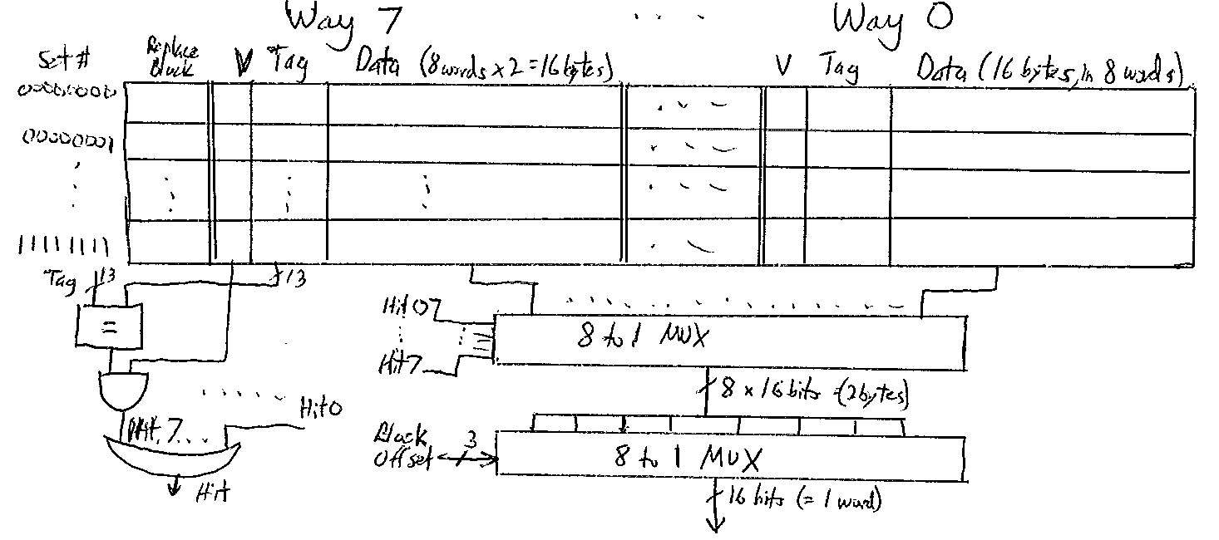

Part 2 [Note: this part is independent from Part 1 above] For the cache given below, each block holds 8 bytes of data. Trace the address reference string and detemine for each address access if it is a Hit or Miss in cache, and if it Evicts something (Y/N), giving the results in the table below. For each Miss, identify the type (Cumpulsory, Conflict or Capacity). In the cache diagram, show the final contents of the cache including LRU, V, Tag and Data for each location that contains a block. The LRU bit shows which way is least recently used. Use the right-hand way (Way0) for first placement of a block into an empty set. The memory reference string is 0x0027, 0x0028, 0x0044, 0x004C, 0x01FF, 0x31F3, 0x31FE, 0xFFFF, 0xFFE0, 0x002F, 0x0144, 0x01F8, 0x01F0, 0x0021. [Note: Assume that memory is byte-addressable, and that cache uses LRU replacement.]

Solution: Since each block holds 8 bytes of data (2 words), the block offset + byte offset together must be 3 bits. Since there are 8 sets, the Set field is 3 bits so the Tag must be 10 bits. Therefore the references, in binary, are:
Tag Set Bl/By off
0000000000 100 111 # 0x0027
0000000000 101 000 # 0x0028
0000000001 000 100 # 0x0044
0000000001 001 100 # 0x004C
0000000111 111 111 # 0x01FF
0011000111 110 011 # 0x31F3
0011000111 111 110 # 0x31FE
1111111111 111 111 # 0xFFFF
1111111111 100 000 # 0xFFE0
0000000000 101 111 # 0x002F
0000000101 000 100 # 0x0144
0000000111 111 000 # 0x01F8
0000000111 110 000 # 0x01F0
0000000000 100 001 # 0x0021

Tracing these references, using LRU, gives the results in the table and cache below:

Hex addr | Binary Addr | Hit or Miss | Evict? Y/N
0x0027 | 0000 0000 0010 0111 | Miss-Compulsory | N
0x0028 | 0000 0000 0010 1000 | Miss-Compulsory | N
0x0044 | 0000 0000 0100 0100 | Miss-Compulsory | N
0x004C | 0000 0000 0100 1100 | Miss-Compulsory | N
0x01FF | 0000 0001 1111 1111 | Miss-Compulsory | N
0x31F3 | 0011 0001 1111 0011 | Miss-Compulsory | N
0x31FE | 0011 0001 1111 1110 | Miss-Compulsory | N
0xFFFF | 1111 1111 1111 1111 | Miss-Compulsory | Y
0xFFE0 | 1111 1111 1110 0000 | Miss-Compulsory | N
0x002F | 0000 0000 0010 1111 | Hit | N
0x0144 | 0000 0001 0100 0100 | Miss-Compulsory | N
0x01F8 | 0000 0001 1111 1000 | Miss-Conflict | Y
0x01F0 | 0000 0001 1111 0000 | Miss-Compulsory | N
0x0021 | 0000 0000 0010 0001 | Hit | N

Way 1 Way 0
Set | LRU | V | Tag | Data | V | Tag | Data
000 | 0 | 1 | 0x005 | M[0x0140-0147] | 1 | 0x001 | M[0x0040-0047]
001 | 1 |  |  |  | 1 | 0x001 | M[0x0048-004F]
010
011
100 | 0 | 1 | 0x3FF | M[0xFFE0-FFE7] | 1 | 0x000 | M[0x0020-0027]
101 | 1 |  |  |  | 1 | 0x000 | M[0x0028-002F]
110 | 0 | 1 | 0x007 | M[0x01F0-01F7] | 1 | 0x0C7 | M[0x31F0-31F7]
111 | 0 | 1 | 0x007 | M[0x01F8-01FF] | 1 | 0x3FF | M[0xFFF8-FFFF]

Question b (Quiz #5 Sec1 Spring 2016) Cache modeling and tracing

Assume a 256-word word-addressable main memory and a four-block direct-mapped cache with two words per block. The cache is initially empty. For the word address reference stream given below, indicate which of the references are hits. Also, show the final contents of the cache. (The word addresses are in decimal.)
2, 10, 3, 26, 12, 4, 12, 10, 5, 12, 6, 10

The cache has 4 lines, or sets, each containing one block, of 2 words. It looks like:
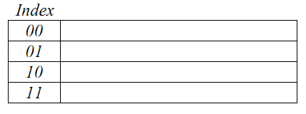
From the problem statement, addresses are 8 bits, with no byte offset, a 1-bit block offset and 2 index bits, and 5 tag bits. Convert the decimal addresses to binary:
2 = 00000010 3 = 00000011 4 = 00000100 5 = 00000101
6 = 00000110 10 = 00001010 12 = 00001100 26 = 00011010

For each memory address, the index bits have been underlined, to make cache tracing easier. Tracing the 12 memory references give the following results, in the 2 table below:

Access:

Cache contents:
start 2 10 3 26 12 4 12 10 5 12 6 10
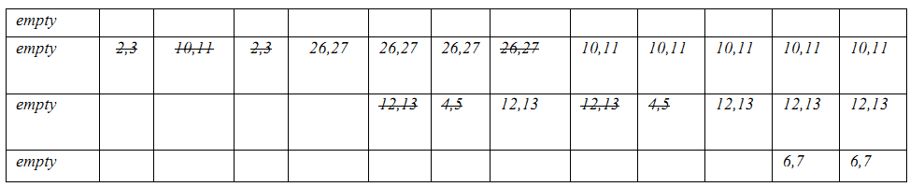

Question 1 (Quiz #5 Sec2/3 Spring 2016) Virtual memory

Consider a virtual memory system that can address a total of 2⁵⁰ bytes. You have unlimited hard drive space, but are limited to 2 GB of semiconductor (physical memory). Assume that virtual and physical pages are each 4 KB in size.

a) How many bits is the physical address?
Since 2 GB = 2³¹ bytes, the physical address is 31 bits

b) What is the maximum number of virtual pages in the system?
The virtual memory is 2⁵⁰ bytes, max. Virtual page size is 4 KB = 2¹² bytes.
Therefore there are 2⁵⁰/2¹² = 2³⁸ = 256 Giga (or ~ 256 billion) virtual pages, max

c) How many physical pages are in the system?
Using the same approach as in b), 2³¹ / 2¹² = 2³¹⁻¹² = 2¹⁹ = 512 Kilo physical pages

d) How many bits are the virtual and physical page numbers?
The virtual page number is 38 bits. The physical page number is 19 bits.

e) How many page table entries will the page table contain?
The page table contains one entry for each virtual page, so 2³⁸ entries

f) Assume that, in addition to the physical page number, each page table entry also contains some status information in the form of a valid bit (V) and a dirty bit (D). How many bytes long is each page table entry? (Round up to an integer number of bytes.)
Physical page numbers are 19 bits, plus the V and D bits, equals 21 bits. So 3 bytes
are needed for each page table entry. (3x8bit)

g) Sketch the layout of the page table. What is the total size of the page table in bytes?
It will be 3 bytes/entry · 2³⁸ entries = 3 · 2³⁸ = 1.5 · 2³⁹ bytes total size.
Nearly 2⁴⁰ = 1 TeraByte in size.
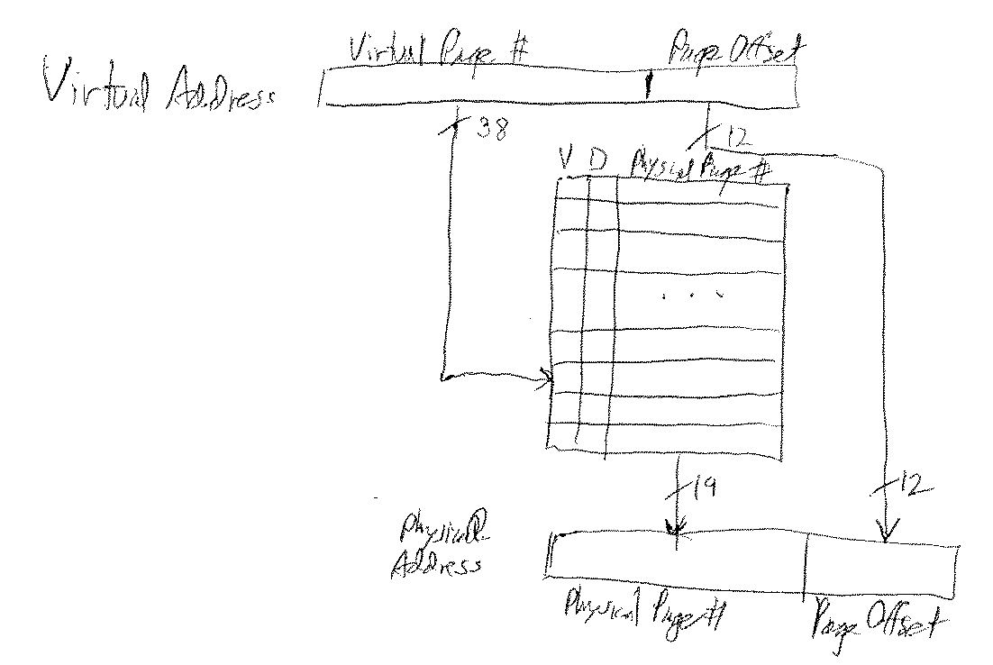

Question 3 (Final Fall 2015) Cache modeling and tracing

Part 1 Using the address format given below and the additional fact that cache is 2-way set associative, answer the following:

Tag Set Bl. Off. By. Off.
24 bits | 12 bits | 5 bits | 3 bit

- What is the data capacity of cache (in bytes)?
(32 word in 1 block = 32 x 64 / 8 byte)
It has 2¹² sets, and each set contains 2¹ blocks, and each block contains 2⁵⁺³ bytes, so the data capacity of cache is 2¹² · 2¹ · 2⁸ = 2²¹ = 2 · 2²⁰ = 2 MBytes

- What is the size of memory (in bytes)?

Memory address is 24+12+5+3 = 44 bits, so its size is 2⁴⁴ = 2⁴ · 2⁴⁰ = 16 Terabytes

- What is the word-size in this processor?

Each byte offset is 3 bits, so word size is 2³ = 8 bytes = 64-bits

d) Where might this processor be used? What kind of application programs might run on it?

This processor is a 64-bit processor, with a big cache (2 MB) and very big main memory capacity (16 TB). It could be used as a server, perhaps as part of a cloud of powerful processors. It may be running very big programs, or running part of very big programs (along with other processors), where performance is important.

Part 2 (16 points) [Note: this part is independent from Part 1 above] For the cache shown on the next page, each block holds 16 words and each word is 32-bits. The cache implements FIFO (first in first out) replacement. Memory is byte addressable. Trace the address reference string and detemine for each address access where it will be located in cache. You should show the final contents of the cache, including the V bit, FIFO bits, Tag and Data contents of each location that contains a block. Assume that empty blocks are filled starting from the left-most way. The FIFO bits should indicate which block is first in (=00), 2nd in (=01), 3rd in (=10), and 4th in (=11). The memory reference string, in order from first reference to last, is 0x0088, 0x018A, 0x0208, 0x054E, 0x03CC, 0x018A, 0x00CE, 0x008C.
Tag Set Bloff Byoff
The references, in binary, are: 0000000 010 0010 00 # 0x0088
0000000 110 0010 10 # 0x018A
0000001 000 0010 00 # 0x0208
0000010 101 0011 10 # 0x054E
0000001 111 0011 00 # 0x03CC
0000000 110 0010 10 # 0x018A
0000000 011 0011 10 # 0x00CE
0000000 010 0011 00 # 0x008C

(Only the left-hand way of the cache contains data blocks! So to make it fit in the page, only 3 ways are shown)
Set | V | FIF0 | Tag | Data | V | FIF0 | Tag | Data | V | FIF0 | Tag | Data
000 | 1 | 00 | 0000001 | M[0x0200-0x023F]
001
010 | 1 | 00 | 0000000 | M[0x0080-0x00BF]
011 | 1 | 00 | 0000000 | M[0x00C0-0x00FF]
100
101 | 1 | 00 | 0000010 | M[0x0540-0x057F]
110 | 1 | 00 | 0000000 | M[0x0180-0x01BF]
111 | 1 | 00 | 0000001 | M[0x03C0-0x03FF]

Question 2 (MT #3 Fall 2015) Cache modeling and tracing

Part 1 Using the address format given below, and the additional fact that cache is direct-mapped, answer the following:
Tag Set Bl. Off. By. Off.
7 bits | 8 bits | 2 bits | 1 bit

- What is the data capacity of cache (in bytes)?
2^8 x 2^2 x 2^1 ( 1 bit byte offset = 16 bit words, 2^8 set and 2^2 words in each block)
2⁸ x 2³ = 2¹¹ = 2048 bytes = 2KB cache

- What is the size of memory (in bytes)?

2¹⁸ = 256 KB memory

- What is the word-size in this processor?

2 bytes/word , so word size is 16-bits

d) Where might this processor be used? What kind of application programs might run on it?

Such a 16-bit processor with small cache and small memory is likely to be embedded in a car or appliance, in a factory or transportation system, etc. It will run small control programs, process signals, do music/audio, etc

Part 2 [Note: this part is independent from Part 1 above] For the cache shown on the next page, each block holds 8 bytes of data. The cache implements LRU replacement. Memory is byte addressable. Trace the address reference string and detemine for each address access where it will be located in cache. You should show the final contents of the cache, including the V bit, LRU bits, Tag and Data contents of each location that contains a block. Assume that empty blocks are filled starting from the left-most way. The LRU bits should indicate which block is least recently used (=00), 2nd least recently used (=01), 2nd most recently used (=10), and most recently used (=11). The memory reference string, in order from first reference to last, is 0x0088, 0x018A, 0x0208, 0x054E, 0x03CC, 0x018A, 0x00CE, 0x008C.

Solution (Left half of cache)
Set | V | LRU | Tag | Data | V | LRU | Tag | Data
000
001 | 1 | 00 | .....0001111 | M[0x 03C8-03CF] | 1 | 01 | ...0000110 | M[0x 0188-018F]
010
011
100
101
110
111

Way 0 Way 1

(Right half of cache)

Set | V | LRU | Tag | Data | V | LRU | Tag | Data
000
001 | 1 | 10 | .....0000011 | M[0x 00C8-00CF] | 1 | 11 | ...0000010 | M[0x 0088-008F]
010
011
100
101
110
111

Way 2 Way 3

Question 4 (MT #2 Fall 2015) Cache modeling and tracing

Part 1 For a 16-bit processor with 1GB address space, connected to a 64KB
8-way set-associative cache with 4096 blocks in the cache, find the following:

- the size of the data portion of each block (in words)

Block size = (64K bytes/cache)/(4K blocks/cache) = 16 bytes/block
Words are 16-bits = 2 bytes/word , so (16 bytes/block)/(2 bytes/word) = 8 words/block

- the number of sets in the cache

Since the cache is 8-way set-associative, there are 8 blocks per set
# sets = (4096 blocks/cache)/(8 blocks/set) = 512 sets /cache

- the number of tag bits in the Tag field of the memory address

1GB addresses means 2³⁰ bytes addresses, so addresses are 30 bits
512 sets: 2⁹ set addresses, so 9 index bits
8 words/block: 2³ block offset addresses, so 3 block offset bits
2 bytes/word: 2¹ byte offset addresses, so 1 byte offset bit
# tag bits = 30 – (9 + 3 + 1) = 17 tag bits
Block Byte
Tag Index offset offset
17 bits | 9 bits | 3 bits | 1

Part 2 For the cache shown on the next page, each block holds 16 bytes of data. Trace the address reference string and detemine for each address access if it is a Hit or a Miss in cache, giving the result in the table on the next page. For each Miss, identify the type (Cumpulsory, Conflict or Capacity). In addition, show the final contents of the cache. Use the left-hand way for first placement of a block into cache. The memory reference string is 0x0027, 0x0028, 0x0044, 0x004C, 0x01FF, 0x31F3, 0x31FE, 0xFFFF, 0xFFE0, 0x002F, 0x0144, 0x11FF, 0x01F0, 0x0021. [Note: Assume that memory is byte-addressable, and that cache uses LRU replacement.]

Hex addr | Binary Addr | Hit or Miss
0x0027 | 0000 0000 0010 0111 | Miss-cold start
0x0028 | 0000 0000 0010 1000 | Hit
0x0044 | 0000 0000 0100 0100 | Miss-cold start
0x004C | 0000 0000 0100 1100 | Hit
0x01FF | 0000 0001 1111 1111 | Miss-cold start
0x31F3 | 0011 0001 1111 0011 | Miss-cold start
0x31FE | 0011 0001 1111 1110 | Hit
0xFFFF | 1111 1111 1111 1111 | Miss-cold start
0xFFE0 | 1111 1111 1110 0000 | Miss-cold start
0x002F | 0000 0000 0010 1111 | Hit
0x0144 | 0000 0001 0100 0100 | Miss-cold start
0x11FF | 0001 0001 1111 1111 | Miss-cold start
0x01F0 | 0000 0001 1111 0000 | Miss-conflict
0x0021 | 0000 0000 0010 0001 | Hit
Block 0x01Fx was in set 1111, then was replaced by LRU, then re-accessed. So the 2nd access is a conflict miss. All other misses are compulsory (or cold-start) misses, caused the first time a block is accessed.

Cache
Set | V | Tag | Data | V | Tag | Data
0000
0001
0010 | 1 | 00000000 | M[0x0020-0x002F]
0011
0100 | 1 | 00000000 | M[0x0040-0x004F] | 1 | 00000001 | M[0x0140-0x014F]
0101
0110
0111
1000
1001
1010
1011
1100
1101
1110 | 1 | 11111111 | M[0xFFE0-0xFFEF]
1111 | 1 | 00000001 | M[0x01F0-0x01FF] | 1 | 00010001 | M[0x11F0-0x11FF]

Question 1 (Classwork Week #11 Fall 2015) Cache Modeling and Tracing

For this problem, an 8-word 2-way set associative cache is used, with block size of 1. The main memory has 16 words, and address references are given as word addresses. The cache uses LRU replacement policy. If both fields for an index are empty, the data should be stored in the left-most field.

- Assuming that the cache is initially empty, for the reference string 1, 2, 3, 4, 5, 9, 1, 2, 3, 5, 1, 9, 10, 12, 2, determine which references are hits and which are misses.

Address | 1 | 2 | 3 | 4 | 5 | 9 | 1 | 2 | 3 | 5 | 1 | 9 | 10 | 12 | 2
Hit/Miss | M | M | M | M | M | M | M | H | H | M | H | M | M | M | H

- Give the final contents of all the Tag and Data fields, after the string of references. (The Tag field should be given in binary, and the Data field should be given in decimal. [Assume that memory location i contains the value i.]

Set Tag Data Tag Data
00 |  | 01 | 4 | 11 | 12
01 |  | 10 | 9 | 00 | 1
10 |  | 00 | 2 | 10 | 10
11 |  | 00 | 3

Question 2 (Classwork Week #11 Fall 2015) Cache Modeling and Tracing

For this problem, a 16-word 2-way set associative cache is used, with block size of 2 words. The main memory has 128 words, and address references are given as word addresses. The cache uses LRU replacement policy. If both fields for an index are empty, the data should be stored in the left-most field.

a) Assuming that the cache is initially empty, for the reference string 1, 2, 3, 4, 5, 9, 1, 2, 3, 5, 1, 9, 10, 12, 2, determine if the reference is a hit or a miss. Put your answer in the table below (H = hit, M = miss)

Address | 1 | 2 | 3 | 4 | 5 | 9 | 1 | 2 | 3 | 5 | 1 | 9 | 10 | 12 | 5 | 6
H/M

Address | 1 | 2 | 3 | 4 | 5 | 9 | 1 | 2 | 3 | 5 | 1 | 9 | 10 | 12 | 5 | 6
H/M | M | M | H | M | H | M | H | H | H | H | H | H | M | M | H | M

b) Give the final contents of all the Tag and Data fields, after the string of references. (The Tag field should be given in binary, and the Data field values should be given in decimal. [Assume that memory location i contains the value i.)]

Set Tag Data Tag Data
00 |  | 0000 | 1,0 | 0001 | 9,8
01 |  | 0000 | 3.2 | 0001 | 11,10
10 |  | 0000 | 5,4 | 0001 | 13,12
11 |  | 0000 | 7,6

Question 1 (Quiz #5 Fall 2015) 2-way set associative cache: modeling and tracing

Consider a byte-addressed memory, of size 64K bytes. The 2-way set-associate cache size is 2K bytes. For this system, word size is 8 bytes, and block size is 8 words.

- Draw the address format, including all fields, with names and widths.
8 bytes/word · 8 words/block = 64 bytes/block [byte offset=3 bits, block offset=3 bits]
(2048 bytes/cache) / (64 bytes/block) = 32 blocks/cache
2 blocks/set · N sets/cache = 32 blocks/cache → N = 16 sets [set index=4 bits]
6 4 3 3
Tag | Index | Block offset | Byte offset

- Draw the cache structure for this system, in the general form of the figures shown in the book. Be sure to include valid and tag bits. Label all fields, with names and widths. Make clear the widths of all data and address busses. Show not just the memory part of the cache, but the logic portions as well.

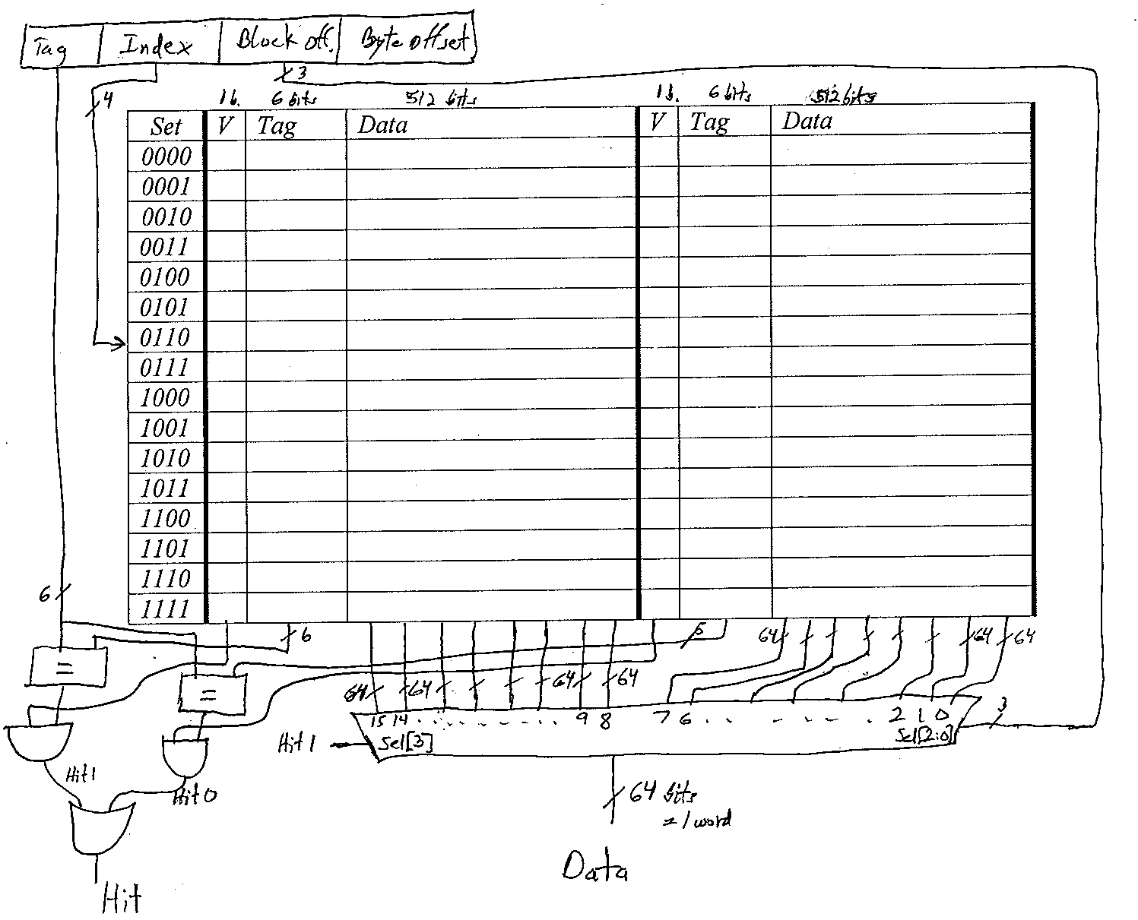

c) Trace address string and detemine for each address access if it is a Hit or a Miss in cache, giving the result in the table below. In additions, show the final contents of the cache, in a cache drawing like that of part b. The memory reference string is 0x23, 0x28, 0x44, 0x45, 0x1FF, 0x31F3, 0x31FE, 0xFFFF, 0xFFE0, 0x2F, 0x144, 0x11FF, 0x12F0, 0x2F. [Note: Assume LRU replacement.]

Hex addr | Binary Addr | Hit or Miss
0x23 | 0000 0000 0010 0011 | Miss-cold start
0x28 | 0000 0000 0010 1000 | Hit
0x44 | 0000 0000 0100 0100 | Miss-cold start
0x45 | 0000 0000 0100 0101 | Hit
0x1FF | 0000 0001 1111 1111 | Miss-cold start
0x31F3 | 0011 0001 1111 0011 | Miss-cold start
0x31FE | 0011 0001 1111 1110 | Hit
0xFFFF | 1111 1111 1111 1111 | Miss-cold start
0xFFE0 | 1111 1111 1110 0000 | Hit
0x2F | 0000 0000 0010 1111 | Hit
0x144 | 0000 0001 0100 0100 | Miss-cold start
0x11FF | 0001 0001 1111 1111 | Miss-cold start
0x12F0 | 0001 0010 1111 0000 | Miss-cold start
0x2F | 0000 0000 0010 1111 | Hit

Set | V | Tag | Data | V | Tag | Data
0000 | 1 | 000000 | M[0x00-0x3F]
0001 | 1 | 000000 | M[0x40-0x7F]
0010
0011
0100
0101 | 1 | 000000 | M[0x140-0x17F]
0110
0111 | 1 | 000100 | M[0x11C0-0x11FF]LRU | 1 | 001100 | M[0x31C0-0x31FF]
1000
1001
1010
1011 | 1 | 000100 | M[0x12C0-0x12FF]
1100
1101
1110
1111 | 1 | 111111 | M[0xFFC0-0xFFFF]

- If the above cache were fully associate, how many comparators would be needed to build it? How many of the above hits would become misses? How many of the above misses would become hits?

The above cache contains 32 blocks, so it would need 32 comparators, if fully-associative. Of the 8 misses, all were cold-start (i.e. compulsory) misses, that would happen no matter what the associativity is. So none of the misses would become hits with full associativity. And none of the hits would become misses in a fully-associative cache.

Question 2 (Quiz #5 Fall 2015) Understanding cache organization and structure

For a 32-bit processor with 4GB address space, connected to a 16KB 4-way set-associative cache with 2048 blocks in the cache, with each block containing Valid, and 2 LRU bits, plus Tag and Data, find the following:

- the size of each data block (in words)

Block size = (16K bytes/cache)/(2K blocks/cache) = 8 bytes/block
Since words are 32-bits = 4 bytes/word, (8 bytes/block)/(4 bytes/word) = 2 words/block

- the number of sets in the cache

Since the cache is 4-way set-associative, there are 4 blocks per set
# bytes per set = 4 blocks/set · 8 bytes/block = 32 bytes/set
# sets = (16K bytes/cache)/(32 bytes/set) = 0.5K sets/cache = 512 sets in the cache

- the number of tag bits in the Tag field of the memory address

4GB addresses means 2³² bytes addresses, so addresses are 32 bits
512 sets: 2⁹ set addresses, so 9 index bits
2 words/block: 2¹ block offset addresses, so 1 block offset bit
4 bytes/word: 2² byte offset addresses, so 2 byte offset bits
# tag bits = 32 – (9 + 1 + 2) = 20 tag bits

- Draw the block diagram of the cache, including the MUXs, gates, and comparators. You don’t need to show the hardware associated with the LRU bits.
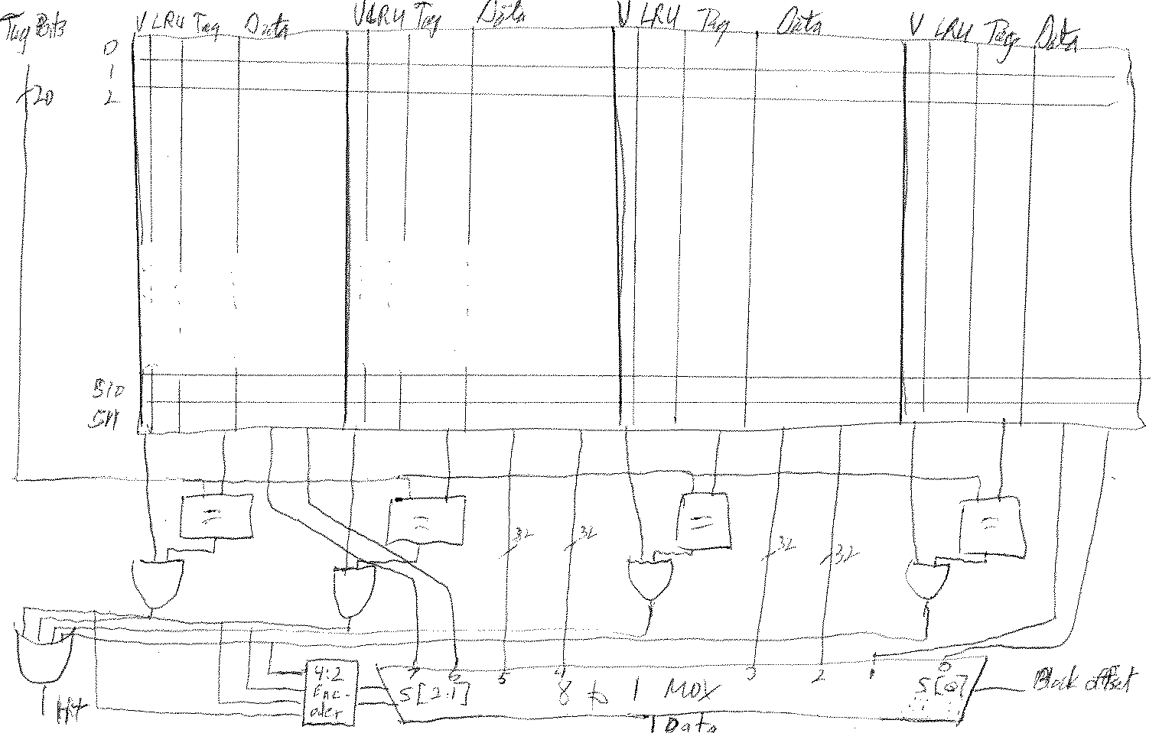

Question 4 (MT #2 Spring 2015): Cache Modeling and Tracing

- Consider a 4 GB byte-addressable main memory with a four-way set-associative cache of 2 MB and 32 bytes per block.
  - How many total blocks are there in cache? Draw the structure of the cache to explain it.
  - Show how the main memory address is partitioned into fields for the cache access and give the bit lengths of those fields.
  - How many tag comparators are there in the cache?

1. 2MB / (32 bytes/block) = 2^21 / 2^5 blocks = 2^16 blocks
Each set contains 4 blocks (since it is 4-way set-associative), so there are 2^14 sets

2. offset bits: log2( 32 ) = 5 [2 are for byte offset (since 4 bytes/word), and 3 for block offset]
index bits: log2( 2^16 / 4 ) = log2( 2^14 ) = 14
tag bits: log2( 4G ) – (14 + 5) = 32 - 19 = 13

13 bits  Tag | 14 bits  Index | 3 bits  Block Offset | 2 bits  Byte Offset

3. There is one per way, and there are 4 ways (or banks) in the cache.

- Assume a 256-word word-addressable main memory and a four-block direct-mapped cache with two words per block. The cache is initially empty. For the word address reference stream given below, indicate which of the references are hits. Also, show the final contents of the cache. (The word addresses are in decimal.)

2, 10, 3, 26, 12, 4, 12, 10, 5, 12, 6, 10

From the problem statement, addresses are 8 bits, with no byte offset, a 1-bit block offset and 2 index bits, and 5 tag bits. Convert the decimal addresses to binary:
2 = 00000010 3 = 00000011 4 = 00000100 5 = 00000101
6 = 00000110 10 = 00001010 12 = 00001100 26= 00011010

For each memory address, the index bits have been underlined, to make cache tracing easier.
Index
00
01
10
11

Access
access | 2-M | 10-M | 3-M | 26-M | 12-M | 4-M | 12-M | 10-M | 5-M | 12-M | 6-M | 10-H

Contents
empty
empty | 2,3 | 10,11 | 2,3 | 26,27 | 26,27 | 26,27 | 26,27 | 10,11 | 10,11 | 10,11 | 10,11 | 10,11
empty |  |  |  |  | 12,13 | 4,5 | 12,13 | 12,13 | 4,5 | 12,13 | 12,13 | 12,13
empty |  |  |  |  |  |  |  |  |  |  | 6,7 | 6,7
Question 3a (Final Exam Spring 2015): Cache Modeling and Performance

a) A computer has a cache of 64KB with a block size of 64 Bytes. Assume that the main memory is a byte-addressable 16MB memory.
i) If the cache is directed mapped, what is the address format used to access this cache? Explain.
ii) If the cache is 2-way associative, what is the address format? Explain.
iii) How would the results to parts i and ii change if block size is 32 Bytes?

Answer:
i) 16MB = 2^24, 24 bits for memory addresses.
64bytes = 2^6, 6 bits for block addresses (including byte offset)
64KB/64 bytes = 1K=2^10, 10 bits for index

8 bits  Tag | 10 bits  Index | 4 bits  Block Offset | 2 bits  Byte Offset

ii) 2-way set associative will reduce the index bit by 1 and increase the tag by 1, therefore

9 bits  Tag | 9 bits  Index | 4 bits  Block Offset | 2 bits  Byte Offset

iii) 32 bytes = 2⁵ bytes. Block size is smaller, therefore there will be more blocks in the cache increasing the index bits for both cases by 1.

8 bits  Tag | 11 bits  Index | 3 bits  Block Offset | 2 bits  Byte Offset

9 bits  Tag | 10 bits  Index | 3 bits  Block Offset | 2 bits  Byte Offset

Question 3 (Final Retake Spring 2015): Cache Modeling

- A computer has a 4-way set associative 1KB cache with a block size of 64 bits. Assume that the main memory is a byte-addressable 64KB memory. Explain the address format used to access this cache in a MIPS-like 32-bit processor.

Answer:

64KB = 2^16, addresses are 16 bits
Block size = 64/8 = 8 bytes = 2^3. So Offset is 3 bits
Byte Offset 2 bits, since there are 4 bytes per word (32-bit word size)
Block Offset 1 bit, since there are 2 words in each 64-bit block
1KB/4 = 2^8 bytes for each way, 2^8/2^3 = 2^5 blocks in each way, therefore Index/Set is 5 bits
Address has 16 bits, 3 are Offset and 5 are Index/Set, so Tag is 8 bits
Tag Set Off.
8 bits | 5 bits | 3 bits

- Consider a direct mapped 1KB cache with a block size of 64 bits, where main memory is a byte-addressable 64KB memory. Consider the following read pattern (addresses) repeats for 100 times assuming that cache replacement policy is LRU:

  - 0x0000
  - 0x0100
  - 0x0200
  - 0x0300
  - 0x1000

What is the hit rate? Explain in detail.

Answer:

Cache is similar to part a, but direct mapped.

64KB = 2^16, addresses are 16 bits
Block size = 64/8 = 8 bytes = 2^3
1KB = 2^10 bytes, 2^10/2^3 = 2^7 blocks in the cache, therefore

Tag: 6 bits
Index/Set: 7 bits
Offset: 3 bits

Expanding the memory references into binary, and grouping by Tag, Index, and Offset:

- 0x0000 => 000000 0000000 000
- 0x0100 => 000000 0100000 000
- 0x0200 => 000000 1000000 000
- 0x0300 => 000000 1100000 000
- 0x1000 => 000100 0000000 000

From this we see that references 1 and 5 are in the same index/set. They will be in conflict and every reference will be a miss. However, references 2, 3, 4 are in different sets. So they will only encounter a compulsory miss the first time they are requested. Subsequent accesses will all be cache hits. So the hit rate is (99*3)/100*5= 297/500 = 59.4%

Question 1 (Quiz #6 Spring 2015) Virtual Memory

Consider a virtual memory system that can address a total of 2⁵⁰ bytes. You have unlimited hard drive space, but are limited to 2 GB of semiconductor (physical memory). Assume that virtual and physical pages are each 4 KB in size.

a) How many bits is the physical address?
Since 2 GB = 2³¹ bytes, the physical address is 31 bits

b) What is the maximum number of virtual pages in the system?
The virtual memory is 2⁵⁰ bytes, max. Virtual page size is 4 KB = 2¹² bytes.
Therefore there are 2⁵⁰⁻¹² = 2³⁸ = 256 Giga (or ~ 256 billion) virtual pages, max

c) How many physical pages are in the system?
Using the same approach as in b), 2³¹ / 2¹² = 2³¹⁻¹² = 2¹⁹ = 512 Kilo physical pages

d) How many bits are the virtual and physical page numbers?
The virtual page number is 38 bits. The physical page number is 19 bits.

e) How many page table entries will the page table contain?
The page table contains one entry for each virtual page, so 2³⁸ entries

f) Assume that, in addition to the shysical page number, each page table entry also contains some status information in the form of a valid bit (V) and a dirty bit (D). How many bytes long is each page table entry? (Round up to an integer number of bytes.)

Physical page numbers are 19 bits, and with the V and D bits, 21 bits, or 3 bytes,
are needed for each page table entry.

g) Sketch the layout of the page table. What is the total size of the page table in bytes?

It will be 3 bytes/entry · 2³⁸ entries = 3 · 2³⁸ = 1.5 · 2³⁹ bytes total size.
Nearly 2⁴⁰ = 1 TeraByte in size.

Question 4 (MT #2 Spring 2014): Cache Memory: Modeling and Tracing

In this question, memory is word-addressable (not byte-addressable, like MIPS). Memory size is 256 MB. Cache size is 256 Bytes. Word size is 64 bits. Block size is 4 words. Cache is direct mapped.

a. For this memory system, give the memory address format. Identify each field and give its width in bits.

Since 1 byte = 8 bits, each word of 64 bits is 64/8 = 8 bytes
Since 256 MB/(8 bytes/word) is 32 Mwords = 2²⁵, the word address will be 25 bits. There is no byte offset field in the address, since bytes are not addressable. (Only words are addressable in word-addressable memory.)

Since each block is 4 words, the block offset field in the address will therefore be 2 bits, to address any of the 4 words in the block.

Block size is 4 words x 8 bytes/word = 32 bytes.
So the cache contains 256 / 32 = 8 blocks. It is direct mapped, which means each set contains 1 block. So there are 8 sets in the cache. The set field in the address will therefore be 3 bits, to address any of the 8 sets.

20 bits 3 bits 2 bits
Tag | Set # | Block offset

b. Draw the cache block diagram for this system. Be sure to include any hardware needed for hit determination.

Set # V Tag Data3 Data2 Data1 Data0
000
001
010
011
100
101
110
111
The additional hardware needed is:
-- four copies (one per way) of the equality detector for Tag matching, followed by the AND gate to check Valid bit, producing Hit0, Hit1, Hit2 and Hit3 signals. The OR of these is the overall Hit signal.
-- a 16-to-1 MUX, to select which of the 16 data words in the set should be sent to the processor when a Hit occurs. 2 of the select bits come from Block Offset, and the other 2 are determined from the 4 HitX bits, which tell which way had the hit.

c. Consider the following memory references given in the left column.

Referenced Memory Location hex: binary (only LSBs are given) | Hit/Miss ( miss type)
1B: 0001 1011 | Miss (CS)
58: 0101 1000 | Miss (CS)
5C: 0101 1100 | Miss (CS)
D7: 1101 0111 | Miss (CS)
58: 0101 1000 | Hit
D7: 1101 0111 | Hit
58: 0101 1000 | Hit
D7: 1101 0111 | Hit
D8: 1101 1000 | Miss (CS)
1C: 0001 1100 | Miss (CS)

In the left column, underline the index (set) field in all of the cases.

In the right column, indicate if the referenced memory location generates a hit or miss. If it is a miss, state what type of miss: Cold Start (CS), Conflict (CO), or Capacity (CA)

In the cache block diagram you drew in part b), show the final contents of the cache, with the value of the Valid bits, the Tag bits, and the range of Data given for each non-empty cache block. In the Data portion of each block, indicate the current contents of the cache memory in terms of address ranges (i.e., from which memory location to which memory location). For example M[7-0] means the memory values from address 0 up to address 7. Express the addresses in decimal.

Set # V Tag Data3 Data2 Data1 Data0
000
001
010
011
100
101 | 1 | …110 | M[215] | M[214] | M[213] | M[212]
110 | 1 | …110 | M[219] | M[218] | M[217] | M[216]
111 | 1 | …000 | M[31] | M[30] | M[29] | M[28]

Question 4 (Final Exam Spring 2014): Cache Memory: Modeling and Tracing

In this question, memory is byte-addressable. Memory size is 1 GB. Cache size is 4096 Bytes. Word size is 16 bits. Block size is 8 words. Cache is 4-way set associative.

a) For this memory system, give the memory address format. Identify each field and give its width in bits.

Word size is 16-bits = 2 bytes. So the byte offset is 1 bit.
Block size is 8 words, so the block offset is 3 bits.
The block size is 16 bytes, so there are 4096/16 = 256 blocks in the cache.
There are 4 blocks per set, since it is 4-way set associative.
Since there are 256/4 = 64 sets in the cache, the index (or set#) is 6 bits
The whole memory is 1 GByte (2³⁰) so it takes 30 bits to address any byte.

The address format is therefore:
20 bits 6 bits 3 bits 1 bit
Tag | Set # | Block offset | Byte o.s.

b) Draw the cache block diagram for this system. Be sure to include any hardware needed for hit determination.

The cache drawing will have:
--4 ways in 4 vertical strips in parallel, each a direct mapped cache
--each way contains 1 block with Valid bit, Tag bits and Data field.
--the labels for V, Tag, and Data are given for each way
--there are 64 sets in the cache, numbered from 0 up to 63
--each way has its own hit determination hardware, consisting of a 20-bit equality detector (one input is the 20-bit Tag field of the address, the other the Tag from the selected set) and an AND gate, which takes the V bit from the selected set and the output of the = HW
--the 4 hit signals are ORed together to form the overall Hit determination of the cache

c) Consider the following string of byte-addressable memory references, applied to a 512 Byte two-way set-associative cache using LRU replacement policy, where words are 32-bits and block size is 4 words.

Ref # | Referenced Memory Location hex: binary (only LSBs are given) | Hit/Miss (miss type)
1 | 0DB: 0000 1101 1011 | Miss (CS)
2 | 1D8: 0001 1101 1000 | Miss (CS)
3 | 25C: 0010 0101 1100 | Miss (CS)
4 | 0D2: 0000 1101 0010 | Hit
5 | 2D8: 0010 1101 1000 | Miss (CS)
6 | 250: 0010 0101 0000 | Hit
7 | 1DF: 0001 1101 1111 | Miss (CO)
8 | 0D5: 0000 1101 0101 | Miss (CO)

In the left column, underline the bits of the index (set) field in all of the cases.

With 4 bytes per word, the address format will have a 2-bit Byte offset field
With 4 words per block, there will be a 2-bit Block offset field.
With 16 bytes per block, there are 512/16 = 32 blocks in the cache. But since it is 2-way set associative, this means there are 16 sets, each containing 2 blocks.
So the middle 4 bits are the set # (or index) bits, the upper 4 are Tag, and the lower 4 are for block and byte offsets.

In the right column, indicate if the referenced memory location generates a hit or miss. If it is a miss, state what type of miss: Cold Start (CS), Conflict (CO), or Capacity (CA)

Note: each wrong answer takes away the value of a correct answer!

When the Tag bits or the Set# bits are different, the reference is to a different block. When they are the same, and only the last 4 bits are different, then the reference is to a different word or byte in the same block.

The first 3 references are all to different blocks not yet in cache (0D, 1D, 25), so they are Cold Start misses, since they are the first reference to these blocks. These 3 blocks are brought in. The 4th reference is to 0D, which is now in the cache, so it is a hit.

The 5th reference (to block 2D) is another Cold Start miss, and when it is brought in, set D is full, so one of the current blocks (0D or 1D) must be evicted. Using LRU replacement policy, 1D is selected to be evicted, it is replaced with block 2D.

The 6th reference is to 25, which is now in the cache, so it is a hit.

The 7th reference is to 1D, which was recently evicted. This is a Conflict miss. Block 1D is brought in, but since set D is full, one of 0D or 2D must be evicted. Using LRU replacement policy, 0D is selected to be evicted, it is replaced with block 1D.

The 8th reference is to 0D, which was just evicted. This is another Conflict miss. Block 0D is brought in, but since set D is full, one of 1D or 2D must be evicted. Using LRU replacement policy, 2D is selected to be evicted, it is replaced with block 0D

Question 4 (Final Retake Spring 2014): Cache Memory and Virtual Memory

a) In this question, memory is byte-addressable. Word size is 32-bits. Block size is 4-words. Replacement policy is LRU. The cache organization is 4-way set-associative, with 64 sets.

For the cache described above, trace the following string of memory references, and determine if each one is a Hit or a Miss, and if it is a miss, determine what type of miss: Cold Start (CS), Conflict (CO), or Capacity (CA):
00FFA, 053FC, 197F4, 00FF6, 063FC, FFFF8, FF0F4, 053F5, 063FB, 197FC

Referenced Memory Location  hex: binary () | Hit/Miss - miss type
00FFA: 0000 0000 1111 1111 1010 | Miss-CS
053FC: 0000 0101 0011 1111 1100 | Miss-CS
197F4: 0001 1001 0111 1111 0100 | Miss-CS
00FF6: 0000 0000 1111 1111 0110 | Hit
063FC: 0000 0110 0011 1111 1100 | Miss-CS
FFFF8: 1111 1111 1111 1111 1000 | Miss-CS
FF0F4: 1111 1111 0000 1111 0100 | Miss-CS
053F5: 0000 0101 0011 1111 0101 | Miss-CO
063FB: 0000 0110 0011 1111 1011 | Hit
197FC: 0001 1001 0111 1111 1100 | Miss-CO

In the left column, underline the index (set) field in all of the cases. In the right column, indicate if the referenced memory location generates a hit or miss. If it is a miss, state what type of miss: Cold Start (CS), Conflict (CO), or Capacity (CA) Note: each wrong answer takes away the value of a correct answer!

b) A virtual memory system can address a total of 4 GB of memory. There are 8 MB of DRAM, and a hard drive much larger than virtual memory. Assume that virtual and physical pages are both 8KB in size.

- How many bits are in the physical address? In the virtual address?
- How many bits are the physical page numbers? The virtual page numbers?
- How many physical pages are in the system? How many virtual pages?
- How many page table entries will the page table contain?
v) Now consider using a TLB to speed up the virtual memory system. For the values given in the table below, what is the average memory access time of the virtual memory system before and after adding the TLB? Assume that the page table is always resident in physical memory and that it is not cached.

Memory Unit | Access Time (cycles) | Miss Rate
TLB | 1 | 0.05%
Cache | 1 | 2%
Main memory | 100 | 0.0003%
Hard drive | 1,000,000 | 0%

i) Physical 23 Virtual 32
ii) Physical 10 Virtual 19
iii) Physical 1024 Virtual 524288 (512K)
iv) 524288
v) AMAT = Virt-to-Phys translation time + MemAccessTime
Before TLB: [100] + [1+ 0.02(100 + 0.000003(1000000))] = 100 + 1 + 2.06 = 103.06
After TLB: [1 + 0.0005(100)] +[ 3.06] = 4.11 cycles

Question 4 (Final Exam Fall 2013): Memory

a) Fill in the empty cells of the following table. Assume that main memory size is 4GB, a word is 32 bits. Index Size: # of bits needed to express the set number in an address, Block Offset: # of bits needed to indicate the word offset in a block, Byte Offset: # of bits needed to indicate the byte offset in a word. Block Replacement Policy Needed: Indicate if a block replacement policy such as FIFO, LRU etc. is needed (yes) or not (no).

# | Cache  Size KB | N- way  cache | Block size  (# of words) | No. of  Sets | Tag Size  in bits | Index Size  (Set No.) in bits | Block  Offset  Size in bits | Byte  Offset  Size in bits | Block  Replacement  Policy Needed (Yes/No)
1 | 128 | 1 | 2 | 2¹⁴ | 15 | 14 | 1 | 2 | No
2 | 512 | 4 | 8 | 2¹² | 15 | 12 | 3 | 2 | Yes
3 | 1024 | Full | 8 | 1 | 27 | 0 | 3 | 2 | Yes

#1: Number of sets= (2⁷ x 2¹⁰) / (1 block/set x 2 words/block x 4 bytes/word) = 2¹⁷/2³= 2¹⁴
#2: Number of sets= (2⁹ x 2¹⁰) / (4 blocks/set x 8 words/block x 4 bytes/word) = 2¹⁹/2⁷= 2¹²
Memory size is 4GB= 4 x 2³⁰ bytes
Tag size= 32 - (index size in bits + block offset size in bits + byte offset size in bits)

b) For # 1, explain your decision for the block replacement policy (i.e., why yes/no)?

In a 1-way cache, it is direct-mapped. There is only one choice to replace a block and therefore no replacement policy is needed.

c) Now consider a fully- associative cache memory that has room for three blocks. In this environment references to various main memory blocks are as follows (the blocks referenced are shown by letters).

A, B, A, C, A, D, D, E, C, A

Show the contents of the cache memory during each memory reference and indicate if there is a hit (H) or miss (M) and calculate the final miss rate. Do this for FIFO and LRU.

For showing the contents of the cache memory and if there is a hit or miss for each reference you are given tables below for FIFO and LRU.

Using FIFO: top-most item is the newest one and bottom-most item is the oldest one, to kick out from the cache.

 | A | B | A | C | A | D | D | E | C | A
Cache  Contents  ==> | A | B | B | C | C | D | D | E | C | A
Cache  Contents  ==> |  | A | A | B | B | C | A | D | E | C
Cache  Contents  ==> |  |  |  | A | A | B | C | A | D | E
H/M==> | M | M | H | M | H | M | H | M | M | M

Final miss rate: 7/ 10= 0.7

Using LRU: top-most item is the most recently used one, and the bottom-most one is least recently used, to kick out from the cache.
 | A | B | A | C | A | D | D | E | C | A
Cache  Contents  ==> | A | B | A | C | A | D | D | E | C | A
Cache  Contents  ==> |  | A | B | A | C | A | A | D | E | C
Cache  Contents  ==> |  |  |  | B | B | C | C | A | D | E
H/M==> | M | M | H | M | H | M | H | M | M | M

Final miss rate: 7/ 10= 0.7

Question 4 (Final Retake Fall 2013): Cache Memory: Modeling and Tracing

In a memory system like MIPS (word size is 32 bits, and using 32 bits for addressing memory) assume a direct-mapped cache memory of size 128 bytes. Block size is given as 4-words. A word is 32 bits.

a. Give the memory address format in terms of its subfields, giving the size of each subfield (tag, etc.).

Block size: 4 words ==> 4 x 4= 16 bytes
No. of blocks in cache memory 128/16= 8
Direct-mapped means 1 block per set ==> 8 sets ==> 3 bits for index field
4 words/block ==> 2 bits for block offset
4 bytes/word ==> 2 bits for byte offset
tag size= 32 - (3 + 2 + 2)= 25 bits
tag index block byte
offset offset
<------------------------><-----------><----------><----------->
25 3 2 2

b. Assuming a valid bit stored with each cache block, how many total bits of storage are needed to implement the cache memory?

8 x (1 + 25 + 4 x 32)= 1232 bits

c. Consider the following memory references given in the table below, left column.

In the left column, underline the index field in all of the cases.

In the middle column, indicate the current contents of the cache memory in terms of address range. Indicate the current contents of the entire cache memory in terms of the address ranges of the blocks that it contains. For example M[0-7] means from address 0 up to address 7. Express the address ranges in decimal.

In the right column, indicate if the referenced memory location generates a hit or miss.

Referenced Memory Location hex: binary | Contents of Cache Memory  Index: M[from, to] See * below to understand how it works | Hit/Miss
1B: 0001 1011 | 001: M[16-31], | M
58: 0101 1000 | 001: M[16-31], 101: M[80-95] | M
5C: 0101 1100 | 001: M[16-31], 101: M[80-95] | H
D7: 1101 0111 | 001: M[16-31], 101: M[208-223] | M
58: 0101 1000 | 001: M[16-31], 101: M[80-95] | M
D7: 1101 0111 | 001: M[16-31], 101: M[208-223] | M
58: 0101 1000 | 001: M[16-31], 101: M[80-95] | M
D7: 1101 0111 | 001: M[16-31], 101: M[208-223] | M
D8: 1101 1000 | 001: M[16-31], 101: M[208-223] | H
1C: 0001 1100 | 001: M[16-31], 101: M[208-223] | H
1B: 0001 1011 | 001: M[16-31], 101: M[208-223] | H
DC: 1101 1100 | 001: M[16-31], 101: M[208-223] | H
59: 0101 1001 | 001: M[16-31], 101: M[80-95] | M
D4: 1101 0100 | 001: M[16-31], 101: M[208-223] | M
1C: 0001 1100 | 001: M[16-31], 101: M[208-223] | H

(*) hex beginning location: memory range in decimal16 bytes M[from-to] 00: M[0-15], 10: M[16-31], 20: M[32-47], 30: M[48-63], 40: M[64-79], 50: M[80-95], 60: M[96-111], 70: M[112-127], 80: M[128-143], 90: M[144-159], A0: M[160-175], B0: M[176-191], C0: M[192-207], D0: M[208-223], E0: M[224-239], F0: M[240-255]

Question 3 (Final Exam Spring 2013): Cache tracing

In this problem, the cache will be used in the memory system of a 32-bit processor like MIPS. Its block size is 8 words, and its overall size is 2K Bytes. It is 2-way set associative, as shown below. Replacement policy is LRU. All cache lines are not shown, only the first few and last few lines. The middle lines of this cache are represented with . . . .

Line # V Tag Data V Tag Data
0
1 | 1 | …0001 | M[1087-1056] | 1 | …0010 | M[2111-2080]
2
. . . . | . | . . . . . . | . . . . . . . . | . | . . . . . . | . . . . . . . .
. . . . | . | . . . . . . | . . . . . . . . | . | . . . . . . | . . . . . . . .
29 | 1 | …0001 | M[1983-1952] | 1 | …0000 | M[959-928]
30
31 | 1 | …0011 | M[4095-4064]

a) Determine the memory address format, and draw a diagram indicating all the fields in the format, and the width of each field.

The number of byte offset bits must be 2, since there are 4 bytes in a 32-bit data word. The number of block offset bits must be 3, since there are 8 words in a block. Therefore there are 32 bytes in each block in cache. Since there are 2 KB total data in cache, there must be (2K bytes/cache)/(32 bytes/block) = 64 blocks/cache. For this cache, with 2 blocks per line, there must be 32 lines in the cache. This requires 5 index bits. All the remaining bits are tag bits. With no other information given about the size of memory, or the size of memory addresses, we can use the fact that the memory system is “like MIPS” to infer a 32-bit addrsess. This means tag field will be 22 bits.

Tag: 22 bits | Index: 5 bits | Block. Off.: 3 bits | Byte Off: 2 bits

b) Number the lines in the cache above, under “Line #”.

Since there are 32 lines in the cache, the addresses will be from 0 to 31

c) Trace the following string of memory address references, and show the final contents of the cache in the diagram above.

For tracing the memory references, it is necessary to find the index bits. Those five bits are the address of the cache line that will be accessed. The 22 tag bits can be abbreviated to the last few least significant bits, since all leading bits are 0s. Since block size is 32 bytes, the data field in cache will contain values like M[X+31 to X], where X is the address of the lowest byte in the block, the byte whose 5 offset bits are 00000.

For tracing purposes, the table below contains the hits and misses, and the block that is replaced if the set is full (i.e if both locations in the line are full), according to LRU policy.

Ref # | Address₁₀ | Address₂ | Hit?
1 | 2999 | ….0010 11101 10111 | Miss: cold-start
2 | 1073 | ….0001 00001 10001 | Miss: cold-start
3 | 2082 | ….0010 00001 00010 | Miss: cold-start
4 | 1952 | ….0001 11101 00000 | Miss: cold-start
5 | 62 | ….0000 00001 11110 | Miss: cold-start
6 | 2101 | ….0010 00001 10101 | Hit
7 | 2983 | ….0010 11101 00111 | Hit
8 | 4070 | ….0011 11111 00110 | Miss: cold-start
9 | 942 | ….0000 11101 01110 | Miss: cold-start,1952 goes out
10 | 1976 | ….0001 11101 11000 | Miss: conflict, 2983 goes out
11 | 1076 | ….0001 00001 10100 | Miss: conflict, 62 goes out

Question 4 (Final Retake Spring 2013): Cache modeling and cache tracing

In this problem part a) and part b) are completely independent from each other.

a) The address format of given computer system with a direct-mapped cache is shown below.

Tag:  11 bits | Index:  8 bits | Block Offset:  4 bits | Byte Offset  1 bit

Starting from the given memory address format:
- (6 pts) Draw a diagram of the cache, numbering the beginning and ending lines.
- (2 pts) What is the size of the cache (bytes of data)?
- (2 pts) What is the size of the main memory (maximum)?

The # of byte offset bits is 1, so there are 2 bytes in a 16-bit data word. The # of block offset bits is 4, so there are 16 words in a block. So there are 2·16 = 32 bytes in each cache block. There are 8 index bits, so there are 2⁸ = 256 cache lines. This is a direct-mapped cache, with 1 block per line, so 256 blocks in the cache. 256 blocks/cache x 32 bytes/block = 8 KB total data in cache. Address size of 24 bits means there is 2²⁴ = 16 Mbytes of memory in this system, maximum.

Line # V Tag Data
0
1
2
. . . . | . | . . . . . . | . . . . . . . .
. . . . | . | . . . . . . | . . . . . . . .
253
254
255

b) (10 points) The 2-way set associative cache shown below is used. It has block size of 16 bytes/block, and uses LRU replacement policy. Trace the string of memory address references given in the table on the next page, and show the final contents in the cache diagram below.

Line # V Tag Data V Tag Data
0
1
2
. . . . | . | . . . . . . | . . . . . . . . | . | . . . . . . | . . . . . . . .
. . . . | . | . . . . . . | . . . . . . . . | . | . . . . . . | . . . . . . . .
61 | 1 | …0011 | M[4063-4048] | 1 | …0010 | M[3039-3024]
62 | 1 | …0001 | M[2031-2016]
63 | 1 | …0011 | M[4095-4080] | 1 | …0010 | M[3071-3056]

Ref # | Address₁₀ | Address₂ | Hit/Miss? What type of miss?
1 | 3031 | ….0010 111101 0111 | Miss: cold-start
2 | 1009 | ….0000 111111 0001 | Miss: cold-start
3 | 978 | ….0000 111101 0010 | Miss: cold-start
4 | 2016 | ….0001 111110 0000 | Miss: cold-start
5 | 990 | ….0000 111101 1110 | Hit
6 | 2037 | ….0001 111111 0101 | Miss: cold-start
7 | 4055 | ….0011 111101 0111 | Miss: cold-start, 3031 goes out
8 | 1014 | ….0000 111111 0110 | Hit
9 | 3070 | ….0010 111111 1110 | Miss: cold-start,2037 goes out
10 | 3032 | ….0010 111101 1000 | Miss: conflict, 990 goes out
11 | 4052 | ….0011 111101 0100 | Hit
12 | 4084 | ….0011 111111 0100 | Miss: cold-start, 1014 goes out

For tracing the memory references, it is necessary to find the index bits. Since there are 16 bytes/block, the last 4 bits are the offset bits. The 6 bits in the middle are the index bits, the address of the particular cache line (from 0 to 63) that will be accessed. The remaining bits to the left are the tag bits. Since block size is 16 bytes, the data field in cache will contain values like M[X+15 to X], where X is the address of the lowest byte in the block, the byte whose 4 offset bits are 0000.

For tracing purposes, the table above contains the hits and misses, and if the set is full (i.e if both locations in the line are full) when a 3rd block is referenced, it shows the block that is replaced (by giving its most-recently accessed address) according to LRU policy.

Question 3 (Prob Set #6 Spring 2013) Cache modeling, and tracing memory reference strings

For a system in which memory references are word, not byte references, and which has a 3-way set-associative cache of size 24 words, where block size is 2 words:

a) Draw the cache structure diagram

Index | V | Tag | Data | V | Tag | Data | V | Tag | Data
00
01
10
11

b) For each of the memory references given in the string below, convert into binary and determine the tag bits, the index bits and the block offset bits.
1 134 212 1 135 213 162 2 44 41 221

First, the memory address format must be determined. 0 byte offset, 1 block offset, and 2 index bits are needed, and all the rest are tag bits (but we don’t know how many).

Tag  (? bits) | Index  (2 bits) | Bl. Off. (1 bit)

Now all the addresses can be broken into their 3 fields:
1 =..0000000001 | ..000000 | 00 | 1
134=..0010000110 | ..010000 | 11 | 0
212=..0011000000 | ..011000 | 00 | 0
1 =..0000000001 | ..000000 | 00 | 1
135= ..0010000111 | ..010000 | 11 | 1
213=..0011000001 | ..011000 | 00 | 1
162=..0010100010 | ..010100 | 01 | 0
2 =..0000000010 | ..000000 | 01 | 0
44=..0000101100 | ..000101 | 10 | 0
41=..0000101001 | ..000101 | 00 | 1
221=..0011001001 | ..011001 | 00 | 1

c) Assuming LRU replacement policy (least recently used), trace the string of references, determine if each reference is a hit or a miss, apply the LRU policy, and show the final cache contents.

1= ..0000000001 | ..000000 | 00 | 1 | Miss
134=..0010000110 | ..010000 | 11 | 0 | Miss
212=..0011000000 | ..011000 | 00 | 0 | Miss
1=..0000000001 | ..000000 | 00 | 1 | Hit
135=..0010000111 | ..010000 | 11 | 1 | Hit
213=..0011000001 | ..011000 | 00 | 1 | Hit
162=..0010100010 | ..010100 | 01 | 0 | Miss
2=..0000000010 | ..000000 | 01 | 0 | Miss
44=..0000101100 | ..000101 | 10 | 0 | Miss
41=..0000101001 | ..000101 | 00 | 1 | Miss
221=..0011001001 | ..011001 | 00 | 1 | Miss

Note that all the misses are cold-start misses, due to first reference to a block, except for the final miss. The final reference, to 221, causes a conflict miss in line #00, so M[1,0] is evicted (it is least recently used) and M[221,220] is placed in the cache.

Index | V | Tag | Data | V | Tag | Data | V | Tag | Data
00 | 1 | ..011001 | M[221,220] | 1 | ..011000 | M[213,212] | 1 | ..000101 | M[41,40]
01 | 1 | ..010100 | M[163,162] | 1 | ..000000 | M[3,2]
10 | 1 | ..000101 | M[45,44]
11 | 1 | ..010000 | M[135,134]

Question 1 (Prob Set #7 Spring 2013) Modeling cache and tracing memory reference string

A parallel multiprocessor has many 64-bit processors, and the maximum amount of byte-addressable memory is 4 TBytes. As part of the memory hierarchy, each processor has its own local L1 cache for data and for instructions. Each L1 cache is 32 KB, 2-way set associative, with LRU replacement policy, and block size of 2 words.

a) Give the memory address format, showing the name of each field and the number of bits in that field.

Tag—28 bits | Index—10 bits | Block offset-- 1 bit | Byte offset -- 3 bits

The 4 TByte (= 2⁴² bytes) address space means addresses must be 42 bits. The 64-bit data words contain 8 bytes, so 3 bits are needed for byte offset. There are 2 words in a block in the L1 cache, so 1 bit of address is needed for block offset. There are 8 x 2 = 16 bytes of data in each block, therefore each 32Kbyte L1 cache contains 32K/16 = 2K blocks. Since it is a 2-way set associative cache, with 2 blocks per cache line (or set) this means there are 1K = 1024 = 2¹⁰ lines in the cache. So the index must be 10 bits, which leaves 42 – (10 + 1 + 3) = 28 bits for the tag field.

b) Draw the cache structure diagram for one of the L1 caches, with each set shown on a single line. Of course you don’t have room to draw all the sets, so draw the first few and the last few and use … in between. For each set show the Valid Bits, the Tags, the Data fields, and of course the address of each set.

Address | V | Tag | DataWord1-- DataWord0 | V | Tag | DataWord1-- DataWord0
0000000000
0000000001
0000000010
. . .
. . .
1111111101
1111111110
1111111111

c) A memory reference string for one of the L1 caches is given below.

i) Translate the decimal addresses into binary, and for each reference, determine if it is a Hit or a Miss. [HINT: divide the binary address bits into the correct fields, to make tracing the string in cache easier.]

Decimal Address | Binary Address | Hit or Miss
16411 | ..0001 0000000001 1011 | Miss--coldstart
48 | ..0000 0000000011 0000 | Miss--coldstart
16407 | ..0001 0000000001 0111 | Hit
32788 | ..0010 0000000001 0100 | Miss--coldstart
16447 | ..0001 0000000011 1111 | Miss--coldstart
60 | ..0000 0000000011 1100 | Hit
49206 | ..0011 0000000011 0110 | Miss--coldstart
16400 | ..0001 0000000001 0000 | Hit
31 | ..0000 0000000001 1111 | Miss--coldstart
88 | ..0000 0000000101 1000 | Miss--coldstart

Note that all the misses are compulsory misses (aka “coldstart” misses) which must
happen the first time a block is referenced. But also note that 2-way associative is not
enough to hold the 3rd block which was referenced in cache line 1 (M[32799 – 32784])
and the 3rd block referenced in cache line 3 (M[16447 – 16432]). If these blocks are
referenced again, they will miss and be brought back in, and another block evicted due to
not enough space at a given cache address. This is called a “conflict” miss.

ii) Show the final contents of the cache (either below, or using the cache you have already drawn in part b). Be sure to indicate the contents of each field in each block, if it is non-empty.

Address | V | Tag | Data | V | Tag | Data
0000000000
0000000001 | 1 | ..0001 | M [16415 – 16400] | 1 | ..0000 | M[31 – 16]
0000000010
0000000011 | 1 | ..0000 | M[63 – 48] | 1 | ..0011 | M[49215 – 49200]
0000000100
0000000101 | 1 | ..0000 | M[95 – 80]
. . .
. . .

